Day 50

DIY

DIY Questions:

Richard has been assigned to work on git. Imagine that he creates a branch, commits a file with the name "login" that contains some content, and then switches to a different branch and also commits a file with the same name but with different contents. He then combines both branches, resulting in merge conflicts. Help Richard to resolve the merge conflicts.

Tasks:

1.Create a working directory and initiate git init

2.Start a new feature branch

3.Create new files and commit file

4.Now switch to the master branch and create a file with the name as login and add some content and commit the changes

5.Switch to the feature branch and create a file with the same name login and add different content and commit the changes.

6.Both the branches should have the same file name but different content.

7.Now merge the master branch to the feature branch

8.You will get merge conflicts

9.Execute the steps to resolve merge conflicts.

Solutions:

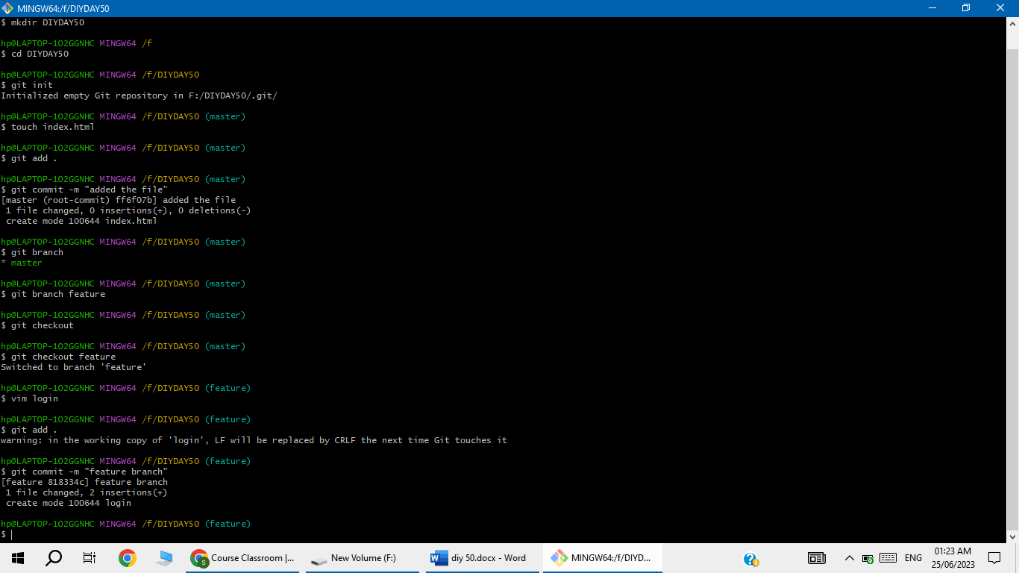

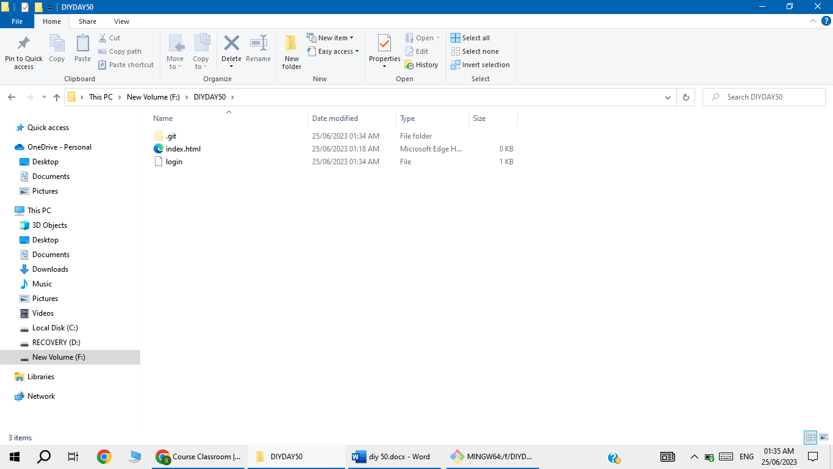

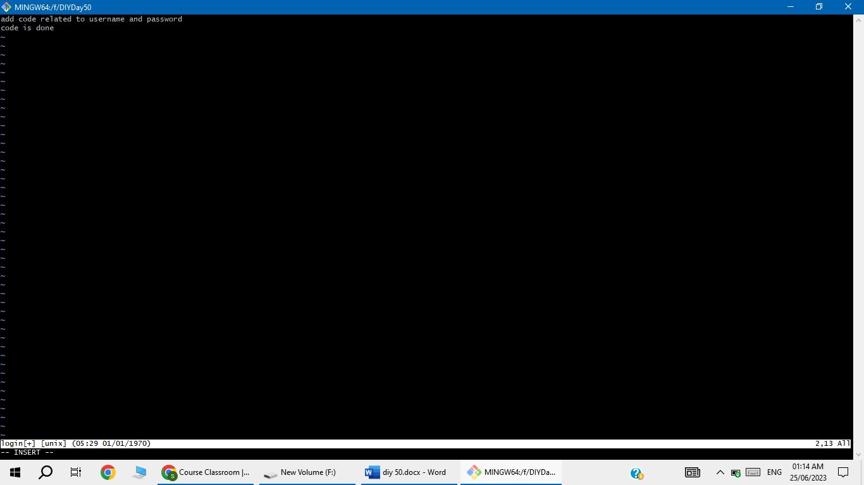

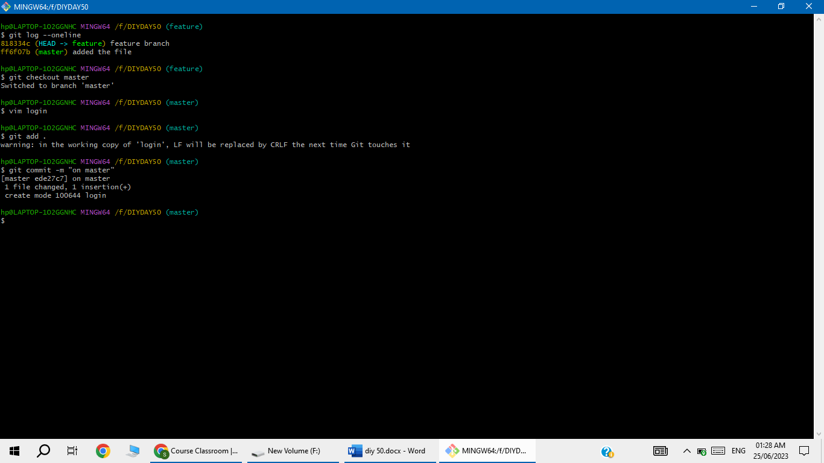

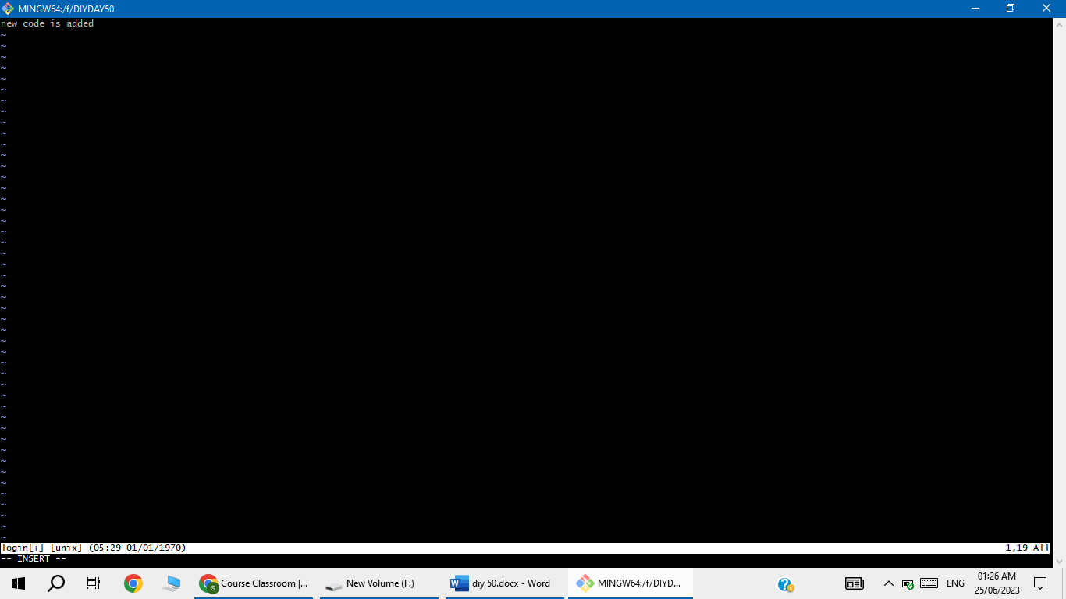

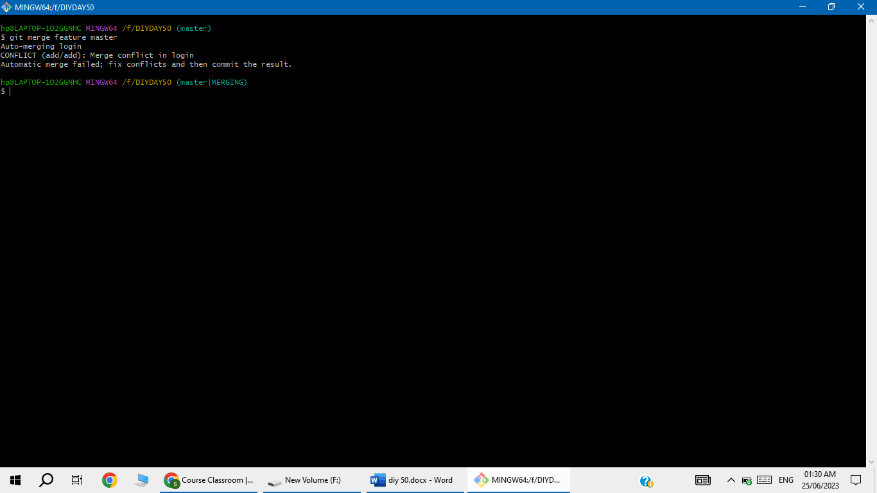

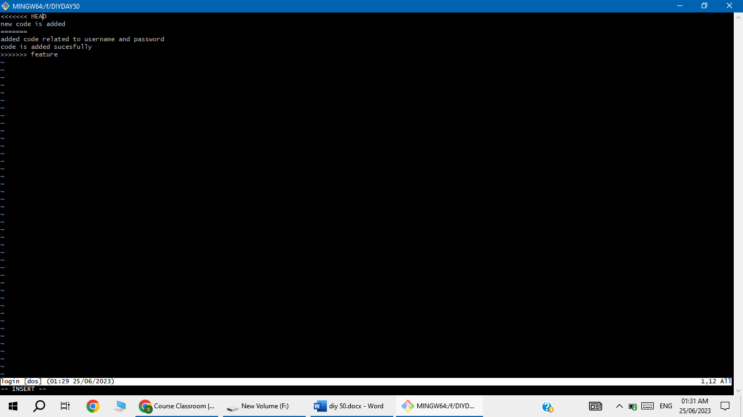

Solve the conflicts problem

